**Testing the Website** [**www.gatesnfences.com**](http://www.gatesnfences.com)

Home page is cut

**Used Device/Browser:**

- Chrome (Version 86.0.4240.198 (Official Build) (64-bit)) on Windows 7

**Steps to reproduce:**

- Open the home page https://laornamental.com/Store/producte33b.html

- The main page is cut and the left side of text cannot be seen

Screenshot:  
  
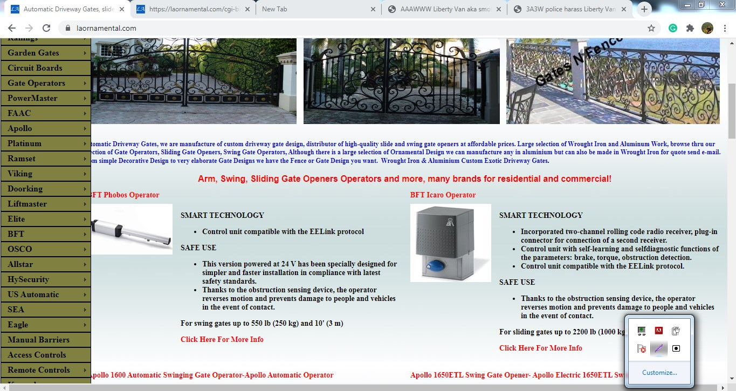

Search bar doesn’t offer a suggestion for a misspelled product

**Used Device/Browser:**

- Chrome (Version 86.0.4240.198 (Official Build) (64-bit)) on Windows 7

**Steps to reproduce:**

- Open the home page https://laornamental.com/index.html

- Click on Enhanced by Google search bar

- Input “”Brittany Speard”

- Click on the Search button

- No result page will be shown

- There will be no suggestion of “Brittany Spears”, the product that exists

Screenshot:  
  
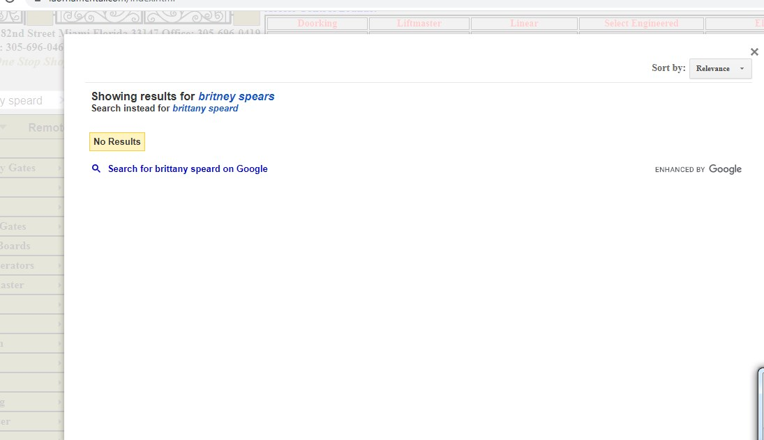

**Comment:**   
For the reference, check the page to see that the “Brittany Spears” product exists on the website

<https://laornamental.com/Store/product5811.html>

The Add to Cart button leads to Cart page

**Used Device/Browser:**

- Chrome (Version 86.0.4240.198 (Official Build) (64-bit)) on Windows 7

**Steps to reproduce:**

- Open the <https://laornamental.com/Store/product72d4.html> page

- Click on the Add to Cart button

- The Cart page will be displayed

- The <https://laornamental.com/Store/product72d4.html> page will be displayed,  
with added product in cart

- The product should be added to the Cart, without leading user to the Cart page

Screen recording:  
  
<https://recordit.co/KR5l0l1V2K>

The Tele Entry Systems Menu is cut

**Used Device/Browser:**

- Chrome (Version 86.0.4240.198 (Official Build) (64-bit)) on Windows 7

**Steps to reproduce:**

- Open the home page https://laornamental.com/Store/producte33b.html

- Click on Tele Entry Systems Tab

- The Tele Entry Systems Menu will be cut on the right side and not be displayed properly

Screen recording:  
  
<https://recordit.co/ljvJfe7TYo>

The Safety Sensors Menu is cut

**Used Device/Browser:**

- Chrome (Version 86.0.4240.198 (Official Build) (64-bit)) on Windows 7

**Steps to reproduce:**

- Open the home page https://laornamental.com/Store/producte33b.html

- Click on Safety Sensors Tab

- The Safety Sensors Menu will be cut on the right side and not displayed properly

Screen recording:  
  
https://recordit.co/pwen9b5moW

The Gate Accessory Menu is cut

**Used Device/Browser:**

- Chrome (Version 86.0.4240.198 (Official Build) (64-bit)) on Windows 7

**Steps to reproduce:**

- Open the home page https://laornamental.com/Store/producte33b.html

- Click on Gate Accessory Tab

- The Gate Accessory Menu will be cut on the bottom and it’s not displayed properly

Screenshot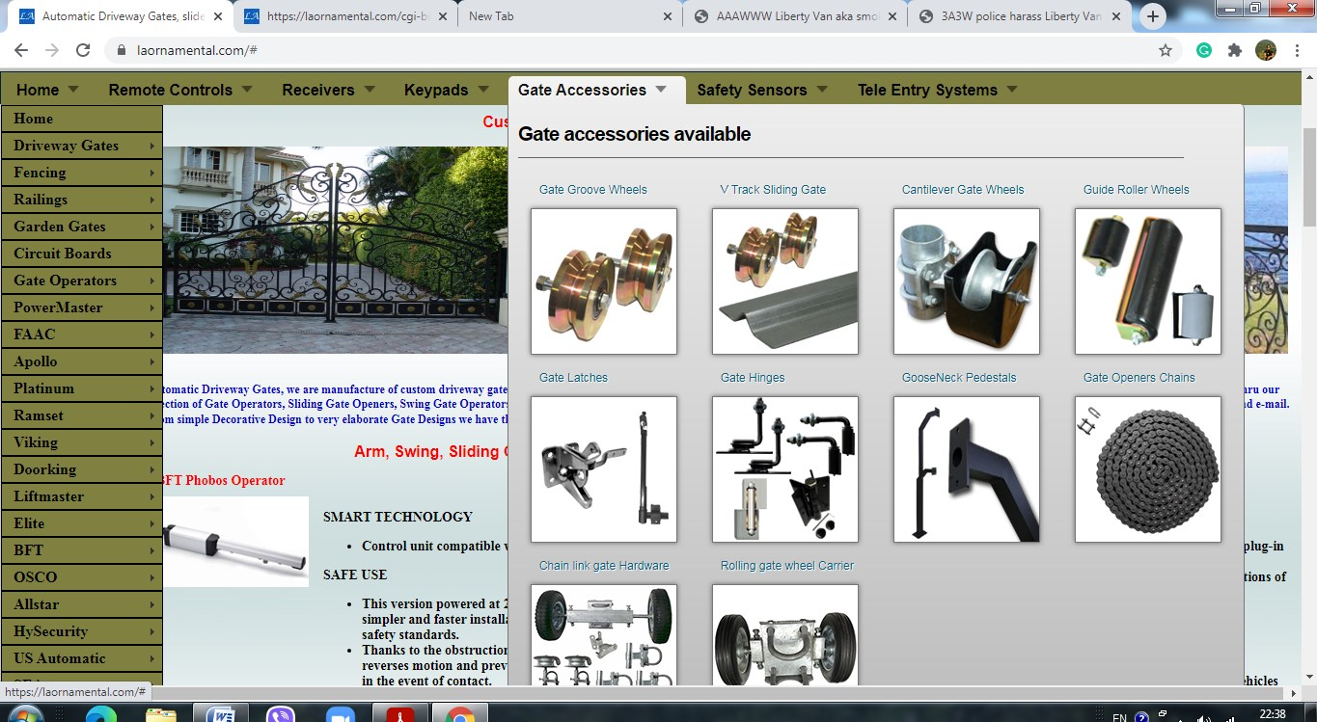:

Broken Images in Receivers

**Used Device/Browser:**

- Chrome (Version 86.0.4240.198 (Official Build) (64-bit)) on Windows 7

**Steps to reproduce:**

- Open the home page https://laornamental.com/Store/producte33b.html

- On the top right, click on the “Receivers” in the table

- Scroll down and the images for “LifMaster”, “Linear” and “Doorking” will be broken

Screenshot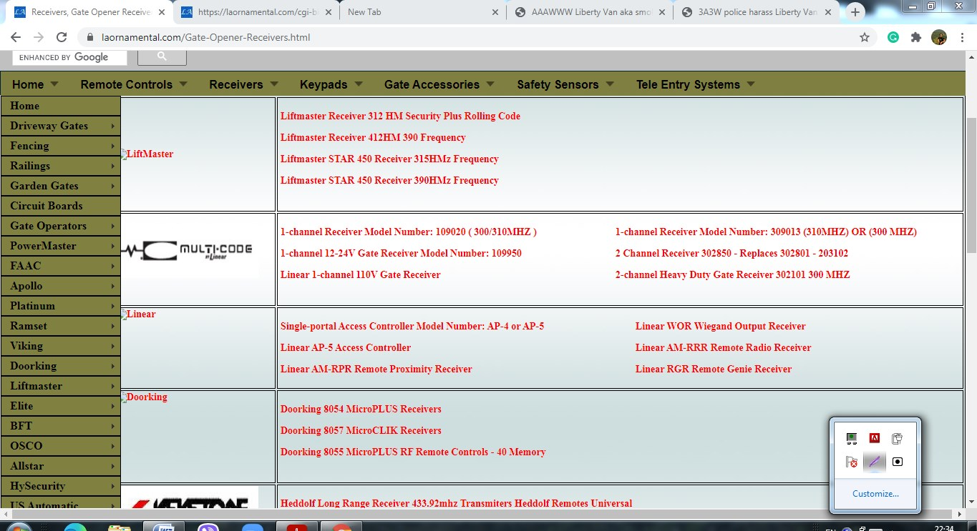

Broken Images in AAS

**Used Device/Browser:**

- Chrome (Version 86.0.4240.198 (Official Build) (64-bit)) on Windows 7

**Steps to reproduce:**

- Open the home page https://laornamental.com/Store/producte33b.html

- On the top right, click on the “AAS” in the table on the top of the page

- Scroll down and the images for multiple products will be broken

Screenshot

